1. Created the LWC component where user can enter the Tracking no in the given text box and click o submit.

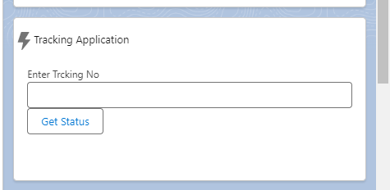

1. On click of submit, the entered tracking no appended to the endpoint and get the response from LW JS await and async functions.
2. The below response from the api will be displayed to user in the LWC page.

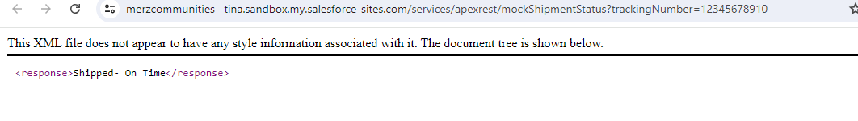

1. The below site should be added in the sandbox CSP Trusted Sites, before hitting the web service.

**https://merzcommunities--tina.sandbox.my.salesforce-sites.com**